**1. NORMAL MODES**

* 1. **AIM**

1. Observe the normal modes of a coupled oscillator.
2. Measure the frequency of normal modes.
   1. **PRINCIPLE**

Two pendulums of particular characteristic frequency coupled by a spiral spring is referred to as a coupled oscillator. This system has two characteristics frequencies, referred to as normal modes. The frequency of individual oscillator is given by –

$$ω_{o}=\frac{mgL}{l}$$

And the two normal mode frequencies are given by -

1. (In – phase osscilation)

2. (Out of phase osscilation)

Where,

*k* - spring constant of the coupling spring spring

*m - mass of* pendulum mass

*g -* acceleration due to gravity

*L* – length of pendulum

*l* - coupling length

**1.3 EQUIPMENTS REQUIRED**

Table I: Equipment and the items required for performing the experiment.

|  |  |  |
| --- | --- | --- |
| ***S. No.*** | ***Required item*** | ***Utility*** |
| *1* | *gravity pendulums(2)* | *To be used as coupled pendulums* |
| *2* | *Spring(1)* | *The spring used for coupling* |
| *3* | *Rotary motion sensor(2)* | *To sense the movement of pendulums while in motion* |
| *4* | *Data logging Interphase(1)* | *To record values and for graphical representation of data* |

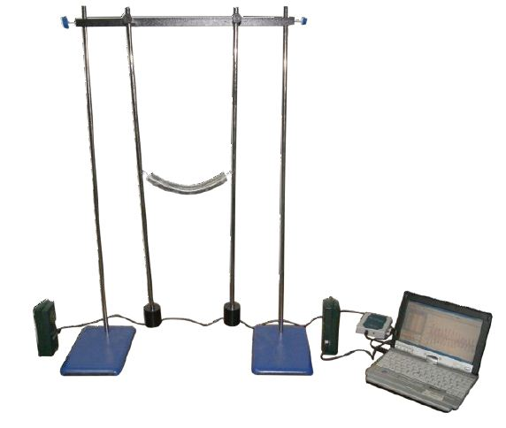

Figure 1: Photograph of the Coupled Oscillations experimental apparatus

**1.4 PROCEDURE**

Three physical quantities need to be measured in this experiment –Angle and Length.

Make the following table –

Table II : The details of the physical quantities to be measured.

|  |  |  |  |  |  |  |
| --- | --- | --- | --- | --- | --- | --- |
| S.No | Physical quantity | Independent /  Dependent | Measured  with | Measuring instrument’s | | |
| Minimum | Maximum | Least count |
| 1 | Time | dependent | stopwatch |  |  |  |
| 2 | Length | Independent | Meter scale |  |  |  |
| 3 | Mass | independent | Weighting machine |  |  |  |

**In-phase oscillation**

1. Displace both the gravity Pendulums by equal amount in the same direction from the equilibrium position.
2. Let it oscillate freely for 5-6 oscillations.|
3. Measure the time taken for ten oscillations.
4. Calculate the time taken for one oscillation and hence the frequency.

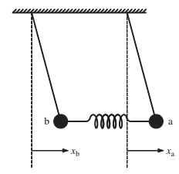

**Out of phase oscillations**.

1. Repeat the steps 1-4 by Displace the Pendulums by equal amount in the opposite direction from the equilibrium position.

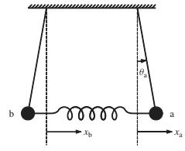

**“Beats” oscillations**

1. Repeat steps 1-4 by displace only one of the pendulums.
2. Observe the motion of both the pendulums.
3. Measure the time taken between two subsequent standstills of a Gravity pendulum. This is called the beat period of the coupled oscillator.
4. Calculate the angular beat frequency.

* 1. **TABLES FOR RECORDING THE DATA**

Table III: In-phase oscillation measurements.

|  |  |  |  |
| --- | --- | --- | --- |
| **Sl. No.** | **Time taken for 10 oscillations** | **Time period $$T_{1}$$** | **Angular frequency $$ω_{1}$$** |
| **1**  **2**  **3** |  |  |  |

Table IV: Anti-phase oscillation measurements.

|  |  |  |  |
| --- | --- | --- | --- |
| **Sl. No.** | **Time taken for 10 oscillations** | **Time period $$T_{2}$$** | **Angular frequency $$ω_{2}$$** |
| **1**  **2**  **3** |  |  |  |

Table V: Beats oscillation measurements.

|  |  |  |
| --- | --- | --- |
| **Sl. No.** | **Beats period $$T_{b}$$** | **Angular beat frequency** |
| **1**  **2**  **3** |  |  |

* 1. **STUDY QUESTIONS**

1. If a coupled system has 4 oscillators, how many normal modes will it have?
2. Can air act as a coupling medium?
3. Can molecular vibrations be considered as coupled oscillations?
4. What are the daily life examples of coupled oscillators?
   1. **FURTHER SCOPE OF EXPERIMENTS**
5. Change the coupling spring and study its affect.
6. To check the linear relation between the square of the coupling lengths and the particular frequencies of the beat mode and square of the frequency for “in opposite phase” vibration.
7. Change the mass and study its affect.
   1. **PRECAUTIONS**
8. Avoid the use of fan while doing the experiment to reduce the interference of the wind.
9. Be careful while handling the Gravity pendulums, which are heavy, to prevent injuries.
   1. **SOURCES OF ERROR**
10. Inaccuracy in the measurement of time.
11. Mass of spring is not taken into consideration.
12. The inaccuracy in the displacement of the Gravity Pendulums by equal distances.

**1.10 THEORY**

* 1. **FURTHER READING AND RESOURCES**

**Text books**

Book – George C. King, 2009. *Vibrations and Waves.* UK, Wiley publications (pp. 78–81).

**Internet**

http://www.theorphys.science.ru.nl/people/fasolino/sub_java/pendula/doublependul-en.shtml

**Java apps/apps**

University of Colorado, B. (n.d.). *Masses & Springs*. Retrieved from PhET Interactive Simulations:[**https://phet.colorado.edu/en/simulation/mass-spring-labA**](https://phet.colorado.edu/en/simulation/mass-spring-labA)

**Videos**

1. Andersen, P. (2014, August). *Simple Harmonic Motion, Bozeman Science*. Retrieved from YouTube: <https://www.youtube.com/watch?v=tudxily5Qu0>
2. Lewin, W. H. (1999). MIT 8.01 Physics I: Classical Mechanics, Fall 1999. *Lecture 10: Hooke's Law - Springs - Simple Harmonic Motion - Pendulum - Small Angle Approximation*. Retrieved from Internet Archive:<https://ia601409.us.archive.org/6/items/MIT8.01F99/10.mp4>

**Bibliography**